
COLLEGE OF COMPUTER STUDIES

CCS007L (COMPUTER PROGRAMMING 2)

EXERCISE
4

STRUCTURES

Student Name / Group Name:
Jed L. Hizon
Name Role

Members (if Group):

AN11 – 2nd Term
Section:

Mr. Mark Cezar
Professor:

I. PROGRAM OUTCOME/S (PO) ADDRESSED BY THE LABORATORY EXERCISE

• Apply knowledge through the use of current techniques and tools necessary for the IT profession. [PO: I]

II. COURSE LEARNING OUTCOME/S (CLO)ADDRESSED BY THE LABORATORY EXERCISE

• Adapt and apply appropriate techniques, resources, and modern computing tools to create computing applications [CLO: 3]

III. INTENDED LEARNING OUTCOME/S (ILO) OF THE LABORATORY EXERCISE

At the end of this exercise, students must be able to:

• Create user- defined types using structures, access its elements and process • Create a record management program.

IV. BACKGROUND INFORMATION

A structure is a group of elements which are of different type. Each of the elements is identified by its own identifier and they are called member.
The format for defining a structure is:

struct MyStructure { Members
};

A structure can be thought of as an object without any member functions. The important

property of structures is that the data in a structure can be a collection of data items of diverse

types.

A structure variable can hold values just like any other variable can. A structure value is a

collection of smaller values called member values.

CCS007L-Computer Programming 2 Page 2 of 6

Here is an example program:

struct database { int id_number; int age;
float salary; };

int main() {
database employee; employee.age = 22; employee.id_number = 1; employee.salary = 12000.21;
}

Structures are used to represent a record, suppose you want to keep track of your books in

a library. You might want to track the following attributes about each book:

• Title

• Author

• Subject

• Book ID

To access any member of a structure, we use the member access operator (the dot

operator). The member access operator is coded as a period between the structure variable name and the structure member that we wish to access. You would use struct keyword to define variables of structure type.

CCS007L-Computer Programming 2 Page 3 of 6

V. GRADING SYSTEM/ RUBRIC

Trait

Requirement Specification(30pts)

Data type(20pts)

Input Validation(20pts)

Free from syntax, logic, and runtime errors (10pts)

Delivery (10pts)

Use of Comments (10pts)
(Excellent) Able to identify
correctly all input and output and provide alternative.
(28-20pts)

Able to apply required data type or data structure and produce correct results (18-20pts)
The program works and meets all specifications. Does exception al checking for errors and out-of- range data (18-20pts) Unable to run program (10pts)

The program was delivered on time (10pts)

Specific purpose is noted for each function, control structure, input requirements, and output results. (10pts)
(Good)
Able to identify correctly all input and output
(25-17pts)

Able to apply required data type or data structure and produce partially correct results (15-17pts) The program works and meets all specifications. Does some checking for errors and out of range data (15-17pts) Able to run program but have logic error (8-9pts)

The program was delivered after 5 minutes from the time required. (8-9pts)

Specific purpose is noted for each function and control structure. (8-9pts)
(Fair)
Able to identify only one input or output (22-14pts)

Able to identify required data type or data structure but does apply correctly (12-14pts)

The program produces correct results but does not display correctly Does not check for errors and out of range data (12-14pts)
Able to run program correctly without any logic error and display inappropriate output (6-7pts)

The program was delivered after 10 minutes from the time required. (6-7pts)

Purpose is noted for each function. (6-7pts)
(Poor) Unable to
identify any input and output
(20-11pts)

Unable to identify required data type
(9-11pts)

The program produce s incorrect results (9-11pts)

Able to run program correctly without any logic error and display appropriate output (5pts) The program was delivered after 15 (or more) minutes from the time required. (5pts)
No comments included. (5pts)

VI. LABORATORY ACTIVITY

CCS007L-Computer Programming 2 Page 4 of 6

INSTRUCTIONS:
Copy your source codes to be pasted in this document as well as a screen shot of your running output.

ACTIVITY 4.1: Player’s Record

Write a C++ program to keep records and compute for the scores of 5 players. The information of each player contains: Nickname, Age and two best played scores.

The program will prompt the user to choose the operation of records from a menu as shown below:

============================================== MENU
============================================== 1. Add record
2. View players records
3. Compute for the average
4. Show the player(s) who gets the max average. 5. Show the player(s) who gets the min average. 6. Exit

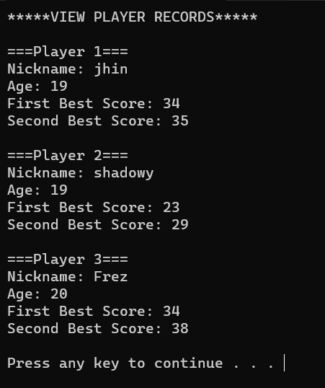
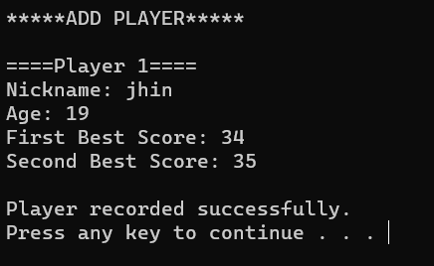
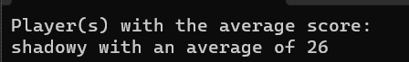
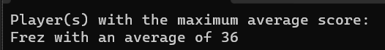
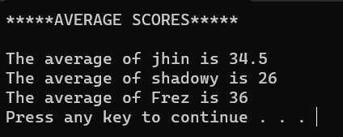
#include <iostream>
#include <string.h>
using namespace std;

struct Player {
string nickname;
int age = 0;
double score1 = 0, score2 =0;
};

void line();
void menu();
void cleanScrn();
void noInput();
void addRecord(Player player[], int& playerNum, int& playerCounter);
void viewRecord(const Player player[], int& playerNum, int& playerCounter);
double computeAverage(const Player& player);
void showMax(const Player player[], int playerNum, int playerCounter);
void showMin(const Player player[], int playerNum, int playerCounter);

int main() {
int choice, playerNum = 0, playerCounter = 0;
Player player[5];
bool checkForRecord = false;

do{
menu();
cin >> choice;

switch(choice){
case 1:
system("cls");
if(playerNum < 5){
addRecord(player, playerNum, playerCounter);
checkForRecord = true;
}
else{
system("cls");
cout << "Player record is full!\n\n";
cleanScrn();
}
break;

case 2:
system("cls");
if(checkForRecord == true){
viewRecord(player, playerNum, playerCounter);
}
else{
noInput();
}
break;

case 3:
system("cls");
if(checkForRecord == true){
cout << "*****AVERAGE SCORES*****\n\n";

playerNum = 0;
for(int i = 0; i < playerCounter; i++){
double result = computeAverage(player[i]);
cout << "The average of " << player[playerNum].nickname << " is " << result << endl;
playerNum++;
}

cleanScrn();
}
else{
noInput();
}
break;
case 4:
system("cls");
showMax(player, playerNum, playerCounter);
break;
case 5:
system("cls");
showMin(player, playerNum, playerCounter);
break;
}
}
while(choice != 6);

return 0;
}

void line(){
for(int i = 0; i < 40; i++){
cout << "=";
}
cout << endl;
}

void cleanScrn(){
system("pause");
system("cls");
}

void menu(){
line();
cout << "\t\tMENU" << endl;
line();
cout << "1. Add record" << endl;
cout << "2. View players record" << endl;
cout << "3. Compute for the average" << endl;
cout << "4. Show the player(s) who gets the max average" << endl;
cout << "5. Show the player(s) who gets the min average" << endl;
cout << "6. Exit\n\n";
cout << "Enter Choice: ";
}

void noInput(){
line();
cout << "\t\tERROR!" << endl;
line();

cout << "Please add a record of a player first." << endl;
cleanScrn();
}

void addRecord(Player player[], int& playerNum, int& playerCounter){
cout << "*****ADD PLAYER*****\n\n";
cout << "====" << "Player " << playerNum + 1 << "====" << endl;

cout << "Nickname: ";
cin >> player[playerNum].nickname;
cout << "Age: ";
cin >> player[playerNum].age;

cout << "First Best Score: ";
cin >> player[playerNum].score1;
cout << "Second Best Score: ";
cin >> player[playerNum].score2;

cout << "\nPlayer recorded successfully.\n";
playerNum++;
playerCounter++;
cleanScrn();
}

void viewRecord(const Player player[], int& playerNum, int& playerCounter){
cout << "*****VIEW PLAYER RECORDS*****\n\n";
playerNum = 0;
for(int i=0; i < playerCounter; i++){
cout << "===Player " << i + 1 << "===" << endl;
cout << "Nickname: " << player[playerNum].nickname << endl;
cout << "Age: " << player[playerNum].age << endl;
cout << "First Best Score: " << player[playerNum].score1 << endl;
cout << "Second Best Score: " << player[playerNum].score2 << endl << endl;
playerNum++;
}
cleanScrn();
}

double computeAverage(const Player& player){
return (player.score1 + player.score2)/2;
}

void showMax(const Player player[], int playerNum, int playerCounter){
double maxAverage = computeAverage(player[0]);

playerNum = 1;
for(int i = 0; i < playerCounter; i++){
double currentAverage = computeAverage(player[i]);
if(currentAverage > maxAverage){
maxAverage = currentAverage;
playerNum = i;
}
}
cout << "Player(s) with the maximum average score: " << endl;
cout << player[playerNum].nickname << " with an average of " << maxAverage << endl;
}

void showMin(const Player player[], int playerNum, int playerCounter){
double minAverage = computeAverage(player[0]);

playerNum = 1;
for(int i = 0; i < playerCounter; i++){
double currentAverage = computeAverage(player[i]);
if(currentAverage < minAverage){
minAverage = currentAverage;
playerNum = i;
}
}
cout << "Player(s) with the average score: " << endl;
cout << player[playerNum].nickname << " with an average of " << minAverage << endl;
}

VII.QUESTION AND ANSWER

Briefly answer the questions below. Avoid erasures. For group activity, specify the name of GROUP MEMBER/s who answered the question. Do not forget to include the source for all NON-ORIGINAL IDEAS.

• What are the ways to use or declare structure in your program?

structures can be declared globally or locally within functions. Global declaration makes the structure accessible throughout the entire program, while local declaration confines its scope to a specific function. Structures can also be defined inside other structures, allowing for hierarchical data organization.

• How do you access a member in a structure?

To access a member in a structure in C++, you use the dot (.) operator followed by the member name. For example, if you have a structure called Person with a member name, you can access it using person.name where person is an instance of the Person structure. This syntax allows you to read or modify the value of the structure's members.

VIII. REFERENCES
• Zak, Dianne (2016). An Introduction to Programming with C++
• Deitel, Paul & Deitel, Harvey (2012). C++ How To Program, Eighth Edition • https://www.cprogramming.com/tutorial/lesson7.html

Page 6 of 6

